'Programmer: Samantha Naini
'Exercise: Chapter 5 Programming Project 1
'Date: 4/22/2012
'Program Purpose: To calculate a student's GPA by entering a letter grade and number of credit hours.

Option Strict On
Option Explicit On

Public Class frmGPA

Dim Grade As Double
Dim CreditHours As Double

Private Sub btnRecordGrades_Click(ByVal sender As System.Object, ByVal e As System.EventArgs) Handles btnRecordGrades.Click

Dim LetterGrade As String
Dim CourseHours As Double

LetterGrade = CStr(txtLetterGrade.Text.ToUpper)
CourseHours = CDbl(txtCreditHrs.Text)

If CourseHours = Nothing Then
MessageBox.Show("Please enter the number of credit hours completed.")
End If

Select Case LetterGrade
Case "A"
Grade += 4.0 * CourseHours
CreditHours += CourseHours
Case "B"
Grade += 3.0 * CourseHours
CreditHours += CourseHours
Case "C"
Grade += 2.0 * CourseHours
CreditHours += CourseHours
Case "D"
Grade += 1.0 * CourseHours
CreditHours += CourseHours
Case "F"
Grade += 0.0 * CourseHours
CreditHours += CourseHours
Case Else
MessageBox.Show("Please enter a valid letter grade.")
End Select

'clears the grade and credit hour textboxes each time the grades are recorded
txtLetterGrade.Clear()
txtCreditHrs.Clear()
txtLetterGrade.Focus()

End Sub

Function CalculateQualityPoints(ByVal CreditHours As Double, ByVal Grade As Double) As Double
Dim GPA As Double
GPA = Grade / CreditHours
Return CDbl(FormatNumber(GPA, 1))
End Function

Private Sub btnCalculateGPA_Click(ByVal sender As System.Object, ByVal e As System.EventArgs) Handles btnCalculateGPA.Click
txtGPA.Text = CStr(CalculateQualityPoints(CreditHours, Grade))
End Sub

Private Sub btnClear_Click(ByVal sender As System.Object, ByVal e As System.EventArgs) Handles btnClear.Click
txtLetterGrade.Clear()
txtCreditHrs.Clear()
txtGPA.Clear()
txtLetterGrade.Focus()
End Sub

Private Sub btnEnd_Click(ByVal sender As System.Object, ByVal e As System.EventArgs) Handles btnEnd.Click

If MsgBox("Do you really want to quit?", MsgBoxStyle.YesNoCancel, "End Program") = MsgBoxResult.Yes Then
MsgBox("have a great day! =)")
Me.Close()
End If
End Sub

End Class
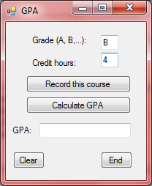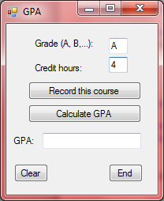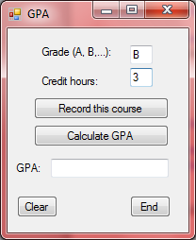
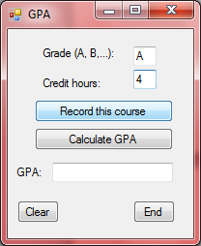 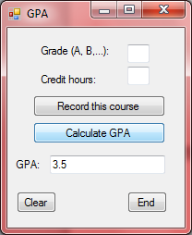 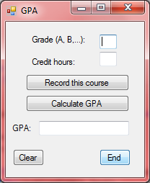←Clear button
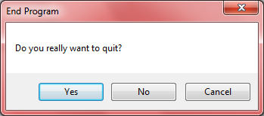 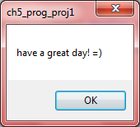←End Button
'Programmer: Samantha Naini
'Exercise: Chapter 5 Programming Project 2
'Date: 4/22/2012
'Program Purpose: Calculating and displaying a restaurant bill.

Option Strict On
Option Explicit On

Public Class frmRestaurantBill

Private Sub btnCompute_Click(ByVal sender As System.Object, ByVal e As System.EventArgs) Handles btnCompute.Click
Dim PizzaSlices, Fries, SoftDrinks As Double

If IsNumeric(txtPizza.Text) And IsNumeric(txtFries.Text) And IsNumeric(txtSoftDrinks.Text) Then

PizzaSlices = CDbl(txtPizza.Text)
Fries = CDbl(txtFries.Text)
SoftDrinks = CDbl(txtSoftDrinks.Text)

Bill(PizzaSlices, Fries, SoftDrinks)

Else
MessageBox.Show("The amount of slices, fries, and/or soft drink orders is invalid. Please try again")
End If
End Sub

Private Sub Bill(ByVal PizzaSlices As Double, ByVal Fries As Double, ByVal SoftDrinks As Double)

Dim CostOfSlices As Double
Dim CostOfFries As Double
Dim CostOfSoftDrinks As Double

CostOfSlices = PizzaSlices * 1.75
CostOfFries = Fries * 2
CostOfSoftDrinks = SoftDrinks * 1.25

'lists the bill in the listbox

lstOutput.Items.Add("ITEM QUANTITY PRICE")
lstOutput.Items.Add("Pizza slices " & PizzaSlices & " " & FormatCurrency(CostOfSlices) & "")
lstOutput.Items.Add("Fries " & Fries & " " & FormatCurrency(CostOfFries) & " ")
lstOutput.Items.Add("Soft Drinks " & SoftDrinks & " " & FormatCurrency(CostOfSoftDrinks) & "")
lstOutput.Items.Add("TOTAL " & FormatCurrency(TotalCost(CostOfSlices, CostOfFries, CostOfSoftDrinks)) & "")

End Sub

Function TotalCost(ByVal CostOfSlices As Double, ByVal CostOfFries As Double, ByVal CostOfSoftDrinks As Double) As Double

Dim Total As Double
Total = CostOfSlices + CostOfFries + CostOfSoftDrinks
Return Total
End Function

Private Sub btnClear_Click(ByVal sender As System.Object, ByVal e As System.EventArgs) Handles btnClear.Click
txtPizza.Clear()
txtFries.Clear()
txtSoftDrinks.Clear()
lstOutput.Items.Clear()
txtPizza.Focus()
End Sub

Private Sub btnEnd_Click(ByVal sender As System.Object, ByVal e As System.EventArgs) Handles btnEnd.Click

If MsgBox("Do you really want to quit?", MsgBoxStyle.YesNoCancel, "End Program") = MsgBoxResult.Yes Then
MsgBox("have a great day! =)")
Me.Close()
End If
End Sub

End Class

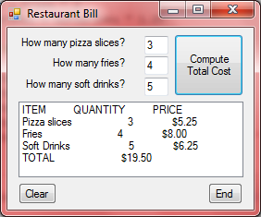
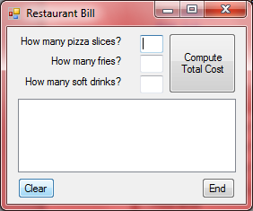←Clear button

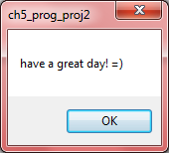←End Button

